Tuesday, September 8  - Find the sum.  - 103 + 89 + 32 =  - 24 + 282 + 57 =  - 98 + 76 + 284 =  - 92 + 308 + 18 =  - 15 + 242 + 154 =  - Write the time shown on each clock.  - 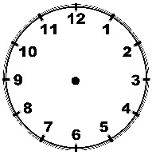 B) 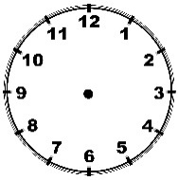  Solve number 3 and 4. Show all work.  - Kingston rode his bike for 45 minutes. He started riding his bike at 1:45. What time did Kingston stop riding his bike?  - Destiny is brother is 12 years old and her sister is 19 years old. The sum of all three of their ages is 40. How old is Destiny? | Wednesday, September 9  1. Find the difference. Remember to copy and show your work.  A) 61 – 23 B) 234 – 84 C) 327 – 48  D) 106 - 47 E) 400 – 183 F) $3.52 – 2.36  2. Copy the number then tell the value of the seven in each number.  A) 1078 B) 742 C) 378 D) 1207  3. Write each measurement in total inches.  A) 1 foot, 2 inches B) 2 feet, 5 inches  4) What is the perimeter of a rectangle with a width of 7 inches and a length of 5 inches?  5) Draw an array to represent 6 by 2.  6) Katie has 16 marbles and half are green. How many green marbles does Katie have?
Thursday, September 10
- Copy, then compare with greater than (>), less than (<), or equal to symbol.
- $\frac{1}{2}$ ⃝ $\frac{4}{5}$ B) $\frac{2}{3}$ ⃝ $\frac{2}{9}$ C) $\frac{3}{9}$ ⃝ $\frac{1}{3}$

- Copy, then compare with greater than (>), less than (<), or equal to symbol.
- 1,832 ⃝ 1,283 B) 3,041 ⃝ 3,140

- How many sides does each shape have?
- pentagon B) triangle
C) parallelogram D) trapezoid

- Jala ate $\frac{3}{8}$ of a sandwich and Dionte ate $\frac{5}{8}$ of the same sandwich. How much of the sandwich did they eat?
- Riddle: I am a 2-digit number less than 30. The sum of my digits is 5. I am an odd number. What number am I?

